**Practical No. 2**

**Aim:** ﻿"City Hospital" has over 200 employee, nurses, ward boys, and other staff, working in three shifts namely morning, evening and night. For smooth functioning of the hospital, the management wants to automate the scheduling and attendance of the employees. At the starting of every week, duties are allotted to the employees. The daily attendance should be recorded. The management also wants to generate a defaulters list reflecting the employees failed to attend their shift on any particular day. Employee can request for a leave with prior intimation, in which case any other staff will have to do overtime, which can be redeemed by leave on some other day for that employee.  
For the above case study  
1. List the classes  
2. Use case diagram  
3. State transition diagram for any one class.

**List Of Contents:**

1. Hospital
2. Employee
   1. Subclass
   2. Nurse
   3. Ward Boy
   4. Other Staff
3. Shift
   1. Subclasses
   2. Morning Shift
   3. Evening Shift
   4. Night Shift
4. Schedule
5. Attendance
6. Management

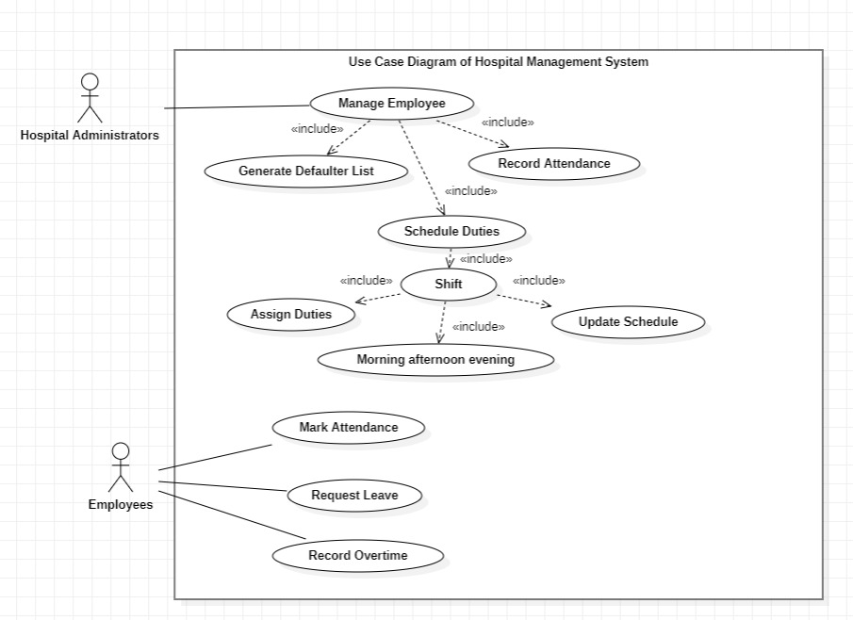

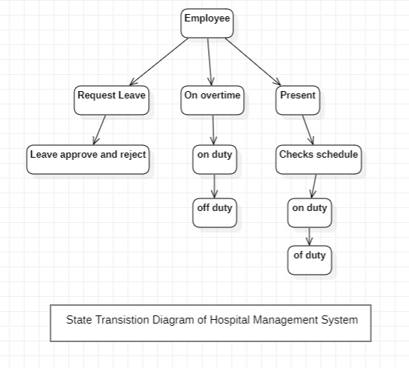

﻿

**Aim:** FastTrack courier service offers domestic services to their clients. The clients are categorized into Frequent (ones sending couriers for at least 10 times in a month) and infrequent. Special discount is offered to the frequent clients. When a shipment is collected from the client, the client details (such as name, address, email, phone number) are recorded for a new client. Shipment may have more than one packet, details of each packet (such as destination address, date of dispatch is recorded. These packets are then assigned to delivery persons for shipping. After the fulfillment, the packet may be delivered or returned due to some reason. The detail of which must be recorded.  
For the above case study, draw  
1. Class diagram  
2. List the use cases  
3. Collaboration diagram for any one-use case

**List Of Contents:**

* Register Client: A new client registers with the courier service.
* Update Client Details: Clients can update their details such as address, email, or phone number.
* Track Shipment: Clients can track the status of their shipment and packet delivery.
* Add Packet to Shipment: The system allows adding one or more packets to a shipment.
* Assign Delivery Person: A delivery person is assigned to a shipment.
* Deliver Packet: The delivery person delivers the packet to the destination address.
* Return Packet: A packet may be returned due to delivery issues, and the return details are recorded.
* Apply Discount: Frequent clients are eligible for a discount, and the discount is applied to their shipment.
* Check Discount Eligibility: The system checks if a client qualifies for a discount based on their shipment history.
* View Shipments: Clients can view their shipment history.
* Update Shipment Status: The system allows updating the shipment's status (e.g., delivered, returned).

